浙江万里学院实验报告
成绩：
教师： 杨立春
课程名称： 图形用户界面设计
实验名称： PyQt5常用控件
专业班级： 姓名： 学号： 日期20251212
实验内容：
1. 登录界面设计：
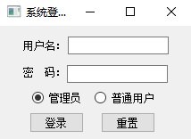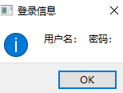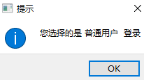
- 代码
Main.py
import sys
from PyQt5.QtWidgets import QApplication, QMainWindow, QPushButton, QVBoxLayout, QWidget,QMessageBox
from untitled import Ui_MainWindow
class Mywindows(QMainWindow, Ui_MainWindow):
chose=0
def __init__(self):
super(Mywindows, self).__init__()
self.setupUi(self)
self.login_button.clicked.connect(self.login)
self.admin_button.clicked.connect(self.admin)
self.user_button.clicked.connect(self.user)
self.reset_button.clicked.connect(self.reset)
def admin(self):
self.chose=1
def user(self):
self.chose=0
def reset(self):
self.username_edit.setText("")
self.passwd_edit.setText("")
def login(self):
QMessageBox.information(self,"登录信息","用户名："+str(self.username_edit.text())+" 密码："+str(self.passwd_edit.text()),QMessageBox.Yes)
if(self.chose==1):
QMessageBox.information(self,"提示","你选择了 管理员 登陆")
else:
QMessageBox.information(self, "提示", "你选择了 用户 登陆")
def open(self):
QMessageBox.information(self,"123","welcome",QMessageBox.Yes)
if __name__ == '__main__':
app = QApplication(sys.argv)
MainWindow = Mywindows()
MainWindow.show()
sys.exit(app.exec_())
Untitled.py
# -*- coding: utf-8 -*-
# Form implementation generated from reading ui file 'untitled.ui'
#
# Created by: PyQt5 UI code generator 5.15.9
#
# WARNING: Any manual changes made to this file will be lost when pyuic5 is
# run again. Do not edit this file unless you know what you are doing.
from PyQt5 import QtCore, QtGui, QtWidgets
class Ui_MainWindow(object):
def setupUi(self, MainWindow):
MainWindow.setObjectName("MainWindow")
MainWindow.resize(405, 232)
self.centralwidget = QtWidgets.QWidget(MainWindow)
self.centralwidget.setObjectName("centralwidget")
self.label = QtWidgets.QLabel(self.centralwidget)
self.label.setGeometry(QtCore.QRect(60, 40, 54, 12))
self.label.setObjectName("label")
self.label_2 = QtWidgets.QLabel(self.centralwidget)
self.label_2.setGeometry(QtCore.QRect(60, 100, 54, 12))
self.label_2.setObjectName("label_2")
self.username_edit = QtWidgets.QLineEdit(self.centralwidget)
self.username_edit.setGeometry(QtCore.QRect(150, 40, 113, 20))
self.username_edit.setObjectName("username_edit")
self.passwd_edit = QtWidgets.QLineEdit(self.centralwidget)
self.passwd_edit.setGeometry(QtCore.QRect(160, 100, 113, 20))
self.passwd_edit.setObjectName("passwd_edit")
self.admin_button = QtWidgets.QRadioButton(self.centralwidget)
self.admin_button.setGeometry(QtCore.QRect(70, 130, 89, 16))
self.admin_button.setObjectName("admin_button")
self.user_button = QtWidgets.QRadioButton(self.centralwidget)
self.user_button.setGeometry(QtCore.QRect(180, 130, 89, 16))
self.user_button.setObjectName("user_button")
self.reset_button = QtWidgets.QPushButton(self.centralwidget)
self.reset_button.setGeometry(QtCore.QRect(60, 150, 75, 23))
self.reset_button.setObjectName("reset_button")
self.login_button = QtWidgets.QPushButton(self.centralwidget)
self.login_button.setGeometry(QtCore.QRect(170, 160, 75, 23))
self.login_button.setObjectName("login_button")
MainWindow.setCentralWidget(self.centralwidget)
self.menubar = QtWidgets.QMenuBar(MainWindow)
self.menubar.setGeometry(QtCore.QRect(0, 0, 405, 23))
self.menubar.setObjectName("menubar")
MainWindow.setMenuBar(self.menubar)
self.statusbar = QtWidgets.QStatusBar(MainWindow)
self.statusbar.setObjectName("statusbar")
MainWindow.setStatusBar(self.statusbar)
self.retranslateUi(MainWindow)
QtCore.QMetaObject.connectSlotsByName(MainWindow)
def retranslateUi(self, MainWindow):
_translate = QtCore.QCoreApplication.translate
MainWindow.setWindowTitle(_translate("MainWindow", "MainWindow"))
self.label.setText(_translate("MainWindow", "用户名"))
self.label_2.setText(_translate("MainWindow", "密码"))
self.admin_button.setText(_translate("MainWindow", "管理员"))
self.user_button.setText(_translate("MainWindow", "用户"))
self.reset_button.setText(_translate("MainWindow", "重置"))
self.login_button.setText(_translate("MainWindow", "登陆"))

2）运行结果
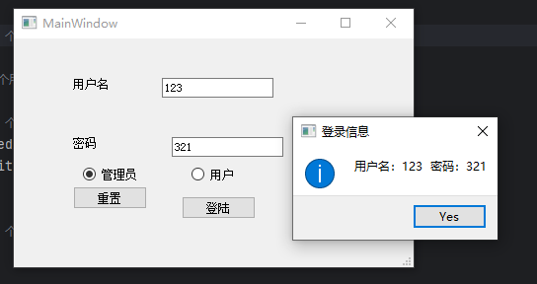
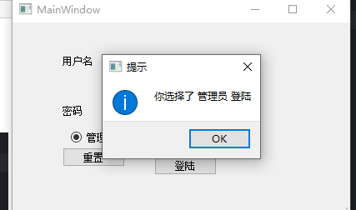
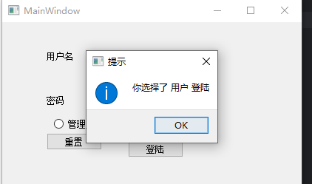

3）理解说明

2.复选框设计
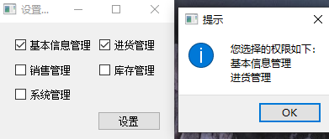

1)代码
Main2.py
import sys
from PyQt5.QtWidgets import QApplication, QMainWindow, QPushButton, QVBoxLayout, QWidget,QMessageBox
from untitled2 import Ui_MainWindow
class Mywindows(QMainWindow, Ui_MainWindow):
s=""
def __init__(self):
super(Mywindows, self).__init__()
self.setupUi(self)
self.pushButton.clicked.connect(self.clicked)
def clicked(self):
if self.jiben.isChecked():
self.s+="\n基本信息管理"
if self.jinhuo.isChecked():
self.s+="\n进货管理"
if self.xiaoshou.isChecked():
self.s+="\n销售管理"
if self.kucun.isChecked():
self.s+="\n库存管理"
if self.xitong.isChecked():
self.s+="\n系统管理"
QMessageBox.information(self,"提示","你选择的权限如下："+self.s)
if __name__ == '__main__':
app = QApplication(sys.argv)
MainWindow = Mywindows()
MainWindow.show()
sys.exit(app.exec_())
Untitled2.py

# -*- coding: utf-8 -*-
# Form implementation generated from reading ui file 'untitled2.ui'
#
# Created by: PyQt5 UI code generator 5.15.9
#
# WARNING: Any manual changes made to this file will be lost when pyuic5 is
# run again. Do not edit this file unless you know what you are doing.
from PyQt5 import QtCore, QtGui, QtWidgets
class Ui_MainWindow(object):
def setupUi(self, MainWindow):
MainWindow.setObjectName("MainWindow")
MainWindow.resize(465, 299)
self.centralwidget = QtWidgets.QWidget(MainWindow)
self.centralwidget.setObjectName("centralwidget")
self.jiben = QtWidgets.QCheckBox(self.centralwidget)
self.jiben.setGeometry(QtCore.QRect(60, 40, 101, 16))
self.jiben.setObjectName("jiben")
self.jinhuo = QtWidgets.QCheckBox(self.centralwidget)
self.jinhuo.setGeometry(QtCore.QRect(220, 40, 71, 16))
self.jinhuo.setObjectName("jinhuo")
self.xiaoshou = QtWidgets.QCheckBox(self.centralwidget)
self.xiaoshou.setGeometry(QtCore.QRect(60, 90, 71, 16))
self.xiaoshou.setObjectName("xiaoshou")
self.kucun = QtWidgets.QCheckBox(self.centralwidget)
self.kucun.setGeometry(QtCore.QRect(230, 90, 71, 16))
self.kucun.setObjectName("kucun")
self.xitong = QtWidgets.QCheckBox(self.centralwidget)
self.xitong.setGeometry(QtCore.QRect(60, 160, 71, 16))
self.xitong.setObjectName("xitong")
self.pushButton = QtWidgets.QPushButton(self.centralwidget)
self.pushButton.setGeometry(QtCore.QRect(220, 190, 75, 23))
self.pushButton.setObjectName("pushButton")
MainWindow.setCentralWidget(self.centralwidget)
self.menubar = QtWidgets.QMenuBar(MainWindow)
self.menubar.setGeometry(QtCore.QRect(0, 0, 465, 23))
self.menubar.setObjectName("menubar")
self.menu = QtWidgets.QMenu(self.menubar)
self.menu.setObjectName("menu")
MainWindow.setMenuBar(self.menubar)
self.statusbar = QtWidgets.QStatusBar(MainWindow)
self.statusbar.setObjectName("statusbar")
MainWindow.setStatusBar(self.statusbar)
self.menubar.addAction(self.menu.menuAction())
self.retranslateUi(MainWindow)
QtCore.QMetaObject.connectSlotsByName(MainWindow)
def retranslateUi(self, MainWindow):
_translate = QtCore.QCoreApplication.translate
MainWindow.setWindowTitle(_translate("MainWindow", "MainWindow"))
self.jiben.setText(_translate("MainWindow", "基本信息管理"))
self.jinhuo.setText(_translate("MainWindow", "进货管理"))
self.xiaoshou.setText(_translate("MainWindow", "销售管理"))
self.kucun.setText(_translate("MainWindow", "库存管理"))
self.xitong.setText(_translate("MainWindow", "系统管理"))
self.pushButton.setText(_translate("MainWindow", "设置"))
self.menu.setTitle(_translate("MainWindow", "设置"))

2）运行结果
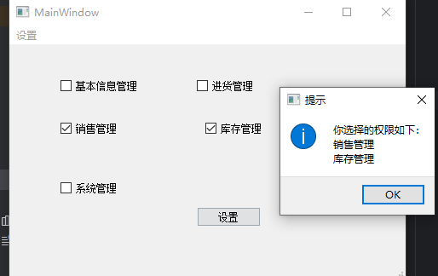

3）理解说明

3.下拉组合框
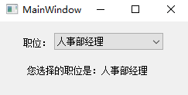
1)代码
Main3.py

import sys
from PyQt5.QtWidgets import QApplication, QMainWindow, QPushButton, QVBoxLayout, QWidget,QMessageBox
from untitled3 import Ui_MainWindow
class Mywindows(QMainWindow, Ui_MainWindow):
s=""
def __init__(self):
super(Mywindows, self).__init__()
self.setupUi(self)
self.comboBox.addItems({"人事部经理","职员"})
self.comboBox.currentIndexChanged.connect(self.change)
def change(self):
self.label_3.setText(str(self.comboBox.currentText()))
if __name__ == '__main__':
app = QApplication(sys.argv)
MainWindow = Mywindows()
MainWindow.show()
sys.exit(app.exec_())
Untitled3.py

# -*- coding: utf-8 -*-
# Form implementation generated from reading ui file 'untitled3.ui'
#
# Created by: PyQt5 UI code generator 5.15.9
#
# WARNING: Any manual changes made to this file will be lost when pyuic5 is
# run again. Do not edit this file unless you know what you are doing.
from PyQt5 import QtCore, QtGui, QtWidgets
class Ui_MainWindow(object):
def setupUi(self, MainWindow):
MainWindow.setObjectName("MainWindow")
MainWindow.resize(475, 285)
self.centralwidget = QtWidgets.QWidget(MainWindow)
self.centralwidget.setObjectName("centralwidget")
self.comboBox = QtWidgets.QComboBox(self.centralwidget)
self.comboBox.setGeometry(QtCore.QRect(140, 80, 181, 31))
self.comboBox.setObjectName("comboBox")
self.label = QtWidgets.QLabel(self.centralwidget)
self.label.setGeometry(QtCore.QRect(80, 90, 54, 12))
self.label.setObjectName("label")
self.label_2 = QtWidgets.QLabel(self.centralwidget)
self.label_2.setGeometry(QtCore.QRect(60, 150, 111, 16))
self.label_2.setObjectName("label_2")
self.label_3 = QtWidgets.QLabel(self.centralwidget)
self.label_3.setGeometry(QtCore.QRect(200, 150, 121, 16))
self.label_3.setText("")
self.label_3.setObjectName("label_3")
MainWindow.setCentralWidget(self.centralwidget)
self.menubar = QtWidgets.QMenuBar(MainWindow)
self.menubar.setGeometry(QtCore.QRect(0, 0, 475, 23))
self.menubar.setObjectName("menubar")
MainWindow.setMenuBar(self.menubar)
self.statusbar = QtWidgets.QStatusBar(MainWindow)
self.statusbar.setObjectName("statusbar")
MainWindow.setStatusBar(self.statusbar)
self.retranslateUi(MainWindow)
QtCore.QMetaObject.connectSlotsByName(MainWindow)
def retranslateUi(self, MainWindow):
_translate = QtCore.QCoreApplication.translate
MainWindow.setWindowTitle(_translate("MainWindow", "MainWindow"))
self.label.setText(_translate("MainWindow", "职位"))
self.label_2.setText(_translate("MainWindow", "你选择的职位是："))

2）运行结果
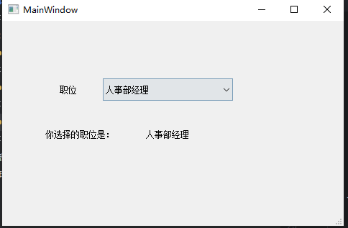

3）理解说明

4.字体组合
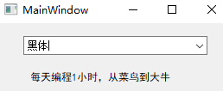
1)代码
Main4.py

import sys
from PyQt5.QtGui import QFont
from PyQt5.QtWidgets import QApplication, QMainWindow, QPushButton, QVBoxLayout, QWidget,QMessageBox
from untitled4 import Ui_MainWindow
class Mywindows(QMainWindow, Ui_MainWindow):
s=""
def __init__(self):
super(Mywindows, self).__init__()
self.setupUi(self)
self.comboBox.addItems({"黑体","宋体","楷体"})
self.comboBox.currentIndexChanged.connect(self.change)
def change(self):
self.label.setFont(QFont(self.comboBox.currentText()))
if __name__ == '__main__':
app = QApplication(sys.argv)
MainWindow = Mywindows()
MainWindow.show()
sys.exit(app.exec_())
Untitled4.py
# -*- coding: utf-8 -*-
# Form implementation generated from reading ui file 'untitled4.ui'
#
# Created by: PyQt5 UI code generator 5.15.9
#
# WARNING: Any manual changes made to this file will be lost when pyuic5 is
# run again. Do not edit this file unless you know what you are doing.
from PyQt5 import QtCore, QtGui, QtWidgets
class Ui_MainWindow(object):
def setupUi(self, MainWindow):
MainWindow.setObjectName("MainWindow")
MainWindow.resize(524, 311)
self.centralwidget = QtWidgets.QWidget(MainWindow)
self.centralwidget.setObjectName("centralwidget")
self.comboBox = QtWidgets.QComboBox(self.centralwidget)
self.comboBox.setGeometry(QtCore.QRect(120, 40, 251, 41))
self.comboBox.setObjectName("comboBox")
self.label = QtWidgets.QLabel(self.centralwidget)
self.label.setGeometry(QtCore.QRect(140, 160, 211, 41))
self.label.setObjectName("label")
MainWindow.setCentralWidget(self.centralwidget)
self.menubar = QtWidgets.QMenuBar(MainWindow)
self.menubar.setGeometry(QtCore.QRect(0, 0, 524, 23))
self.menubar.setObjectName("menubar")
MainWindow.setMenuBar(self.menubar)
self.statusbar = QtWidgets.QStatusBar(MainWindow)
self.statusbar.setObjectName("statusbar")
MainWindow.setStatusBar(self.statusbar)
self.retranslateUi(MainWindow)
QtCore.QMetaObject.connectSlotsByName(MainWindow)
def retranslateUi(self, MainWindow):
_translate = QtCore.QCoreApplication.translate
MainWindow.setWindowTitle(_translate("MainWindow", "MainWindow"))
self.label.setText(_translate("MainWindow", "每天编程1小时，从菜鸟到大牛"))

2）运行结果
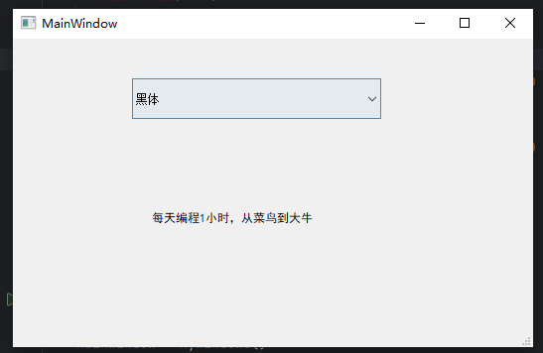

3）理解说明

5. 列表：
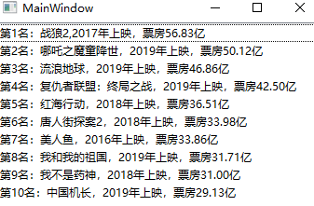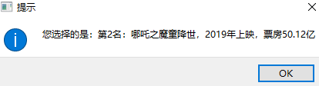
- 代码
Main5.py
import sys
from PyQt5.QtGui import QFont
from PyQt5.QtWidgets import QApplication, QMainWindow, QPushButton, QVBoxLayout, QWidget,QMessageBox
from untitled5 import Ui_MainWindow
class Mywindows(QMainWindow, Ui_MainWindow):
s=""
def __init__(self):
super(Mywindows, self).__init__()
self.setupUi(self)
self.listWidget.addItem("第一名：战狼2")
self.listWidget.addItem("第二名：哪吒")
self.listWidget.itemClicked.connect(self.clicked)
def clicked(self):
QMessageBox.information(self,"title","你选择了"+self.listWidget.currentItem().text())
if __name__ == '__main__':
app = QApplication(sys.argv)
MainWindow = Mywindows()
MainWindow.show()
sys.exit(app.exec_())
Untitled5.py

# -*- coding: utf-8 -*-
# Form implementation generated from reading ui file 'untitled5.ui'
#
# Created by: PyQt5 UI code generator 5.15.9
#
# WARNING: Any manual changes made to this file will be lost when pyuic5 is
# run again. Do not edit this file unless you know what you are doing.
from PyQt5 import QtCore, QtGui, QtWidgets
class Ui_MainWindow(object):
def setupUi(self, MainWindow):
MainWindow.setObjectName("MainWindow")
MainWindow.resize(628, 492)
self.centralwidget = QtWidgets.QWidget(MainWindow)
self.centralwidget.setObjectName("centralwidget")
self.listWidget = QtWidgets.QListWidget(self.centralwidget)
self.listWidget.setGeometry(QtCore.QRect(70, 40, 256, 192))
self.listWidget.setObjectName("listWidget")
MainWindow.setCentralWidget(self.centralwidget)
self.menubar = QtWidgets.QMenuBar(MainWindow)
self.menubar.setGeometry(QtCore.QRect(0, 0, 628, 23))
self.menubar.setObjectName("menubar")
MainWindow.setMenuBar(self.menubar)
self.statusbar = QtWidgets.QStatusBar(MainWindow)
self.statusbar.setObjectName("statusbar")
MainWindow.setStatusBar(self.statusbar)
self.retranslateUi(MainWindow)
QtCore.QMetaObject.connectSlotsByName(MainWindow)
def retranslateUi(self, MainWindow):
_translate = QtCore.QCoreApplication.translate
MainWindow.setWindowTitle(_translate("MainWindow", "MainWindow"))

2）运行结果
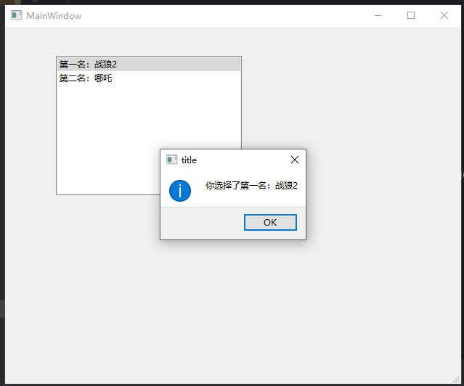

3）理解说明

6.选项卡
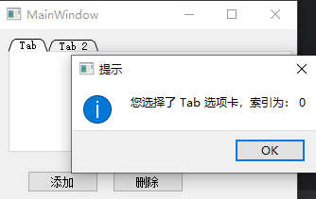
1)代码
Main6.py

import sys
from PyQt5.QtGui import QFont
from PyQt5.QtWidgets import QApplication, QMainWindow, QPushButton, QVBoxLayout, QWidget,QMessageBox
from untitled6 import Ui_MainWindow
class Mywindows(QMainWindow, Ui_MainWindow):
s=""
def __init__(self):
super(Mywindows, self).__init__()
self.setupUi(self)
self.tabWidget.currentChanged.connect(self.tab_clicked)
def tab_clicked(self):
QMessageBox.information(self,"title","你选择了"+self.tabWidget.tabText(self.tabWidget.currentIndex())+" 索引为"+str(self.tabWidget.currentIndex()),QMessageBox.Ok)
if __name__ == '__main__':
app = QApplication(sys.argv)
MainWindow = Mywindows()
MainWindow.show()
sys.exit(app.exec_())
Untitled6.py

# -*- coding: utf-8 -*-
# Form implementation generated from reading ui file 'untitled6.ui'
#
# Created by: PyQt5 UI code generator 5.15.9
#
# WARNING: Any manual changes made to this file will be lost when pyuic5 is
# run again. Do not edit this file unless you know what you are doing.
from PyQt5 import QtCore, QtGui, QtWidgets
class Ui_MainWindow(object):
def setupUi(self, MainWindow):
MainWindow.setObjectName("MainWindow")
MainWindow.resize(686, 532)
self.centralwidget = QtWidgets.QWidget(MainWindow)
self.centralwidget.setObjectName("centralwidget")
self.tabWidget = QtWidgets.QTabWidget(self.centralwidget)
self.tabWidget.setGeometry(QtCore.QRect(80, 70, 271, 181))
self.tabWidget.setObjectName("tabWidget")
self.tab = QtWidgets.QWidget()
self.tab.setObjectName("tab")
self.tabWidget.addTab(self.tab, "")
self.tab_2 = QtWidgets.QWidget()
self.tab_2.setObjectName("tab_2")
self.tabWidget.addTab(self.tab_2, "")
self.addbutton = QtWidgets.QPushButton(self.centralwidget)
self.addbutton.setGeometry(QtCore.QRect(100, 320, 75, 23))
self.addbutton.setObjectName("addbutton")
self.delbutton = QtWidgets.QPushButton(self.centralwidget)
self.delbutton.setGeometry(QtCore.QRect(220, 320, 75, 23))
self.delbutton.setObjectName("delbutton")
MainWindow.setCentralWidget(self.centralwidget)
self.menubar = QtWidgets.QMenuBar(MainWindow)
self.menubar.setGeometry(QtCore.QRect(0, 0, 686, 23))
self.menubar.setObjectName("menubar")
MainWindow.setMenuBar(self.menubar)
self.statusbar = QtWidgets.QStatusBar(MainWindow)
self.statusbar.setObjectName("statusbar")
MainWindow.setStatusBar(self.statusbar)
self.retranslateUi(MainWindow)
QtCore.QMetaObject.connectSlotsByName(MainWindow)
def retranslateUi(self, MainWindow):
_translate = QtCore.QCoreApplication.translate
MainWindow.setWindowTitle(_translate("MainWindow", "MainWindow"))
self.tabWidget.setTabText(self.tabWidget.indexOf(self.tab), _translate("MainWindow", "Tab 1"))
self.tabWidget.setTabText(self.tabWidget.indexOf(self.tab_2), _translate("MainWindow", "Tab 2"))
self.addbutton.setText(_translate("MainWindow", "添加"))
self.delbutton.setText(_translate("MainWindow", "删除"))

2）运行结果
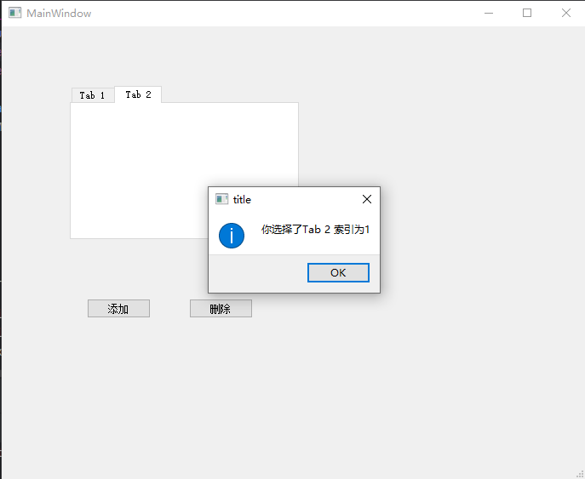

3）理解说明

7.工具盒
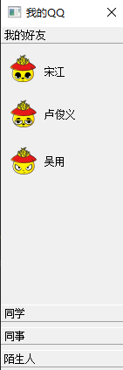
1)代码
import sys
import os
from PyQt5.QtWidgets import (
QApplication, QMainWindow, QTreeWidget, QTreeWidgetItem,
QVBoxLayout, QWidget, QMessageBox
)
from PyQt5.QtGui import QIcon
# 确保 icons 目录存在（可选）
ICON_DIR = "icons"
if not os.path.exists(ICON_DIR):
os.makedirs(ICON_DIR)
class QQFriendList(QMainWindow):
def __init__(self):
super().__init__()
self.setWindowTitle("QQ 好友列表")
self.resize(300, 500)
# 创建中心控件
central_widget = QWidget()
self.setCentralWidget(central_widget)
layout = QVBoxLayout()
central_widget.setLayout(layout)
# 创建 QTreeWidget
self.tree = QTreeWidget()
self.tree.setHeaderHidden(True) # 隐藏表头
self.tree.itemClicked.connect(self.on_item_clicked)
layout.addWidget(self.tree)
# 构建好友列表
self.build_friend_list()
def build_friend_list(self):
# 分组1：我的好友
group1 = QTreeWidgetItem(["我的好友"])
group1.setExpanded(True)
self.tree.addTopLevelItem(group1)
self.add_friend(group1, "宋江", "icons/cj.png")
self.add_friend(group1, "卢俊义", "icons/ljy.png")
self.add_friend(group1, "吴用", "icons/wy.png")
# 分组2：同学
group2 = QTreeWidgetItem(["同学"])
group2.setExpanded(True)
self.tree.addTopLevelItem(group2)
self.add_friend(group2, "张三", "icons/zs.png")
self.add_friend(group2, "李四", "icons/ls.png")
# 分组3：同事
group3 = QTreeWidgetItem(["同事"])
group3.setExpanded(False) # 默认折叠
self.tree.addTopLevelItem(group3)
self.add_friend(group3, "王五", "icons/wu.png")
self.add_friend(group3, "赵六", "icons/zl.png")
# 分组4：陌生人（无好友）
group4 = QTreeWidgetItem(["陌生人"])
group4.setExpanded(True)
self.tree.addTopLevelItem(group4)
def add_friend(self, parent, name, icon_path):
item = QTreeWidgetItem([name])
# 如果图标文件存在，则设置图标
if os.path.exists(icon_path):
item.setIcon(0, QIcon(icon_path))
else:
# 可选：使用默认用户图标（这里用空白，或可用 Qt 内置图标）
pass
parent.addChild(item)
def on_item_clicked(self, item, column):
# 判断是否是好友项（不是分组）
if item.parent() is not None: # 有父节点 → 是好友
name = item.text(0)
QMessageBox.information(self, "提示", f"你选择了：{name}")
# 如果点击的是分组（parent is None），可以忽略或处理展开逻辑
if __name__ == '__main__':
app = QApplication(sys.argv)
window = QQFriendList()
window.show()
sys.exit(app.exec_())

2）运行结果
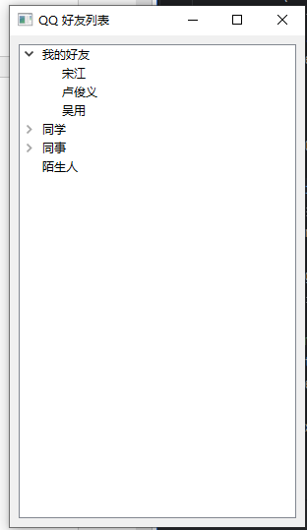

3）理解说明

8.日期时间
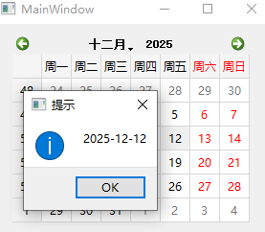1)代码
Main7.py

import sys
from PyQt5.QtGui import QFont
from PyQt5.QtWidgets import QApplication, QMainWindow, QPushButton, QVBoxLayout, QWidget,QMessageBox
from untitled7 import Ui_MainWindow
class Mywindows(QMainWindow, Ui_MainWindow):
s=""
def __init__(self):
super(Mywindows, self).__init__()
self.setupUi(self)
self.calendarWidget.clicked.connect(self.calendar_clicked)
def calendar_clicked(self):
QMessageBox.information(self,"t",self.calendarWidget.selectedDate().toString("yyyy-MM-dd"))
if __name__ == '__main__':
app = QApplication(sys.argv)
MainWindow = Mywindows()
MainWindow.show()
sys.exit(app.exec_())
Untitled7.py

# -*- coding: utf-8 -*-
# Form implementation generated from reading ui file 'untitled7.ui'
#
# Created by: PyQt5 UI code generator 5.15.9
#
# WARNING: Any manual changes made to this file will be lost when pyuic5 is
# run again. Do not edit this file unless you know what you are doing.
from PyQt5 import QtCore, QtGui, QtWidgets
class Ui_MainWindow(object):
def setupUi(self, MainWindow):
MainWindow.setObjectName("MainWindow")
MainWindow.resize(800, 600)
self.centralwidget = QtWidgets.QWidget(MainWindow)
self.centralwidget.setObjectName("centralwidget")
self.calendarWidget = QtWidgets.QCalendarWidget(self.centralwidget)
self.calendarWidget.setGeometry(QtCore.QRect(190, 90, 248, 197))
self.calendarWidget.setObjectName("calendarWidget")
MainWindow.setCentralWidget(self.centralwidget)
self.menubar = QtWidgets.QMenuBar(MainWindow)
self.menubar.setGeometry(QtCore.QRect(0, 0, 800, 23))
self.menubar.setObjectName("menubar")
MainWindow.setMenuBar(self.menubar)
self.statusbar = QtWidgets.QStatusBar(MainWindow)
self.statusbar.setObjectName("statusbar")
MainWindow.setStatusBar(self.statusbar)
self.retranslateUi(MainWindow)
QtCore.QMetaObject.connectSlotsByName(MainWindow)
def retranslateUi(self, MainWindow):
_translate = QtCore.QCoreApplication.translate
MainWindow.setWindowTitle(_translate("MainWindow", "MainWindow"))

2）运行结果
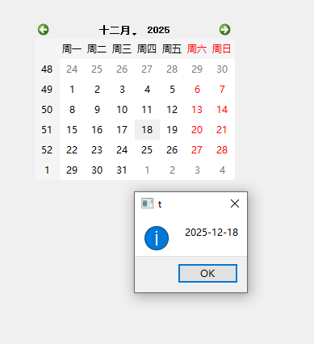

3）理解说明

